NEWSLETTER APRIL 2022

WOODLEY BAPTIST CHURCH PRESCHOOL

Friday 8th April 2022

Dear Parents/Carers,

With Easter falling later this year we finish the Spring Term today, Friday 8th April 2022, returning to Preschool on Monday 25th April 2022.

We hope the children have had fun with all our activities this term from such things as celebrating Valentine’s Day and Mother’s Day, developing number & counting skills, discovering shadows and exploring light & dark and in this last week focusing on the true meaning of Easter. We also celebrated World Book Day on 3rd March 2022 with the children wearing some fantastic costumes and sharing their favourite stories. As Covid rules have relaxed we have been able to have a visit from Claire from Wokingham Libraries reading new books to the children, as well as a dance session this week with Hannah.
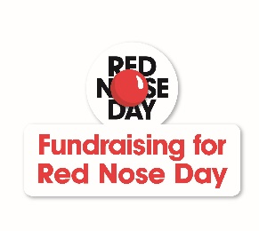
The children helped us to raise a fantastic £60.00 for Comic Relief by coming to Preschool dressed in red, taking part in a red nose competition & decorating cakes to take home. Well done to Vyom and Lacie for winning the competition with their lovely creations. Thank you to everyone for taking part and supporting this charity fund raiser in these difficult times.

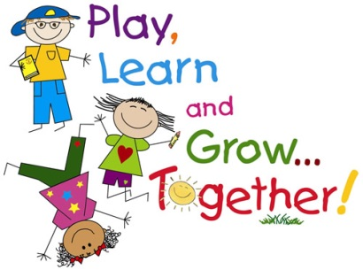
Everyone should by now have spoken to their child’s Key Person and read the Spring Term reports. These will be published on Tapestry during the Easter break. Thank you for joining us for these appointments to discuss your child’s learning journey at Preschool. As always, we have received very positive feedback about what we do at Preschool and the learning opportunities provided for all the children. As you have seen, the children continue to be busy learning through play. The next step for most is preparing for their transition to school in September 2022.

With this in mind, by now you will have all received letters with the sad news that for a number of reasons, Preschool will be closing permanently as this year ends. We will not dwell on this matter here in our Newsletter, as hopefully everything has been explained in the letters sent out. The children will still enjoy the last term together & the staff remain dedicated to being part of their journey onto school. We have had some lovely messages of support at this difficult time for both staff and Committee, so thank you all.
A reminder to parents of children going to school in September, you should be notified of their place by Tuesday 19th April 2022. When you return to us the following week we will be asking for confirmation of where your child will be going, so we can begin the transition process. The deadline for accepting places is Wednesday 4th May 2022. Please also let us know as soon as you have any details about school visits. Thank you.

As you will know most rules and regulations around COVID-19 have been lifted, but please be aware that cases are still increasing in the borough. Unless there are any changes over the Easter break, for the Summer Term, we ask that you continue to wear face coverings when dropping off/collecting and to use the hand sanitisers provided. Please do not attend if you or your child has any symptoms.

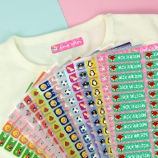
Don’t forget to make sure everything that is brought into Preschool is clearly named, especially coats and bags. This is really helpful to both children and staff when friends have very similar items and when we need to find a change of clothes. We want to continue limiting what comes into Preschool at this time, so please do not leave other items with the children, such as umbrellas & toys from home. Don’t forget, for safety reasons we do not want plastic or drawstring bags in Preschool and no medication, food or drink items in bags from home. Thank you.
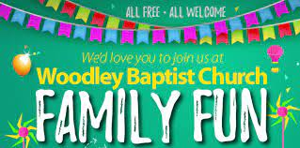
There are several activities happening during the Easter holidays at the Church including a Family Fun Day and a Coffee Morning Craft session. Please see the leaflets attached to this Newsletter and go to http://www.woodleybc.org/calendar/ for more information.

Please see below some of the main dates for the Summer Term. We will be CLOSED on Thursday 5th May 2022 as the Church building is to be used as a Polling station for the upcoming local elections. Please also note the May Bank Holiday.

DATES FOR DIARIES:
END OF SPRING TERM – Friday 8th April 2022
START OF SUMMER TERM – Monday 25th April 2022
MAY BANK HOLIDAY – Monday 2nd May 2022 – PRESCHOOL CLOSED
POLLING DAY – Thursday 5th May 2022 – PRESCHOOL CLOSED
HALF TERM – Monday 30th May – Friday 3rd June 2022
END OF SUMMER TERM – Thursday 21st July 2022

There is an additional inset day in lieu of the extra Bank Holiday for the Queen’s Jubilee to be confirmed.

If any of your contact details have recently changed, especially mobile phone numbers and email addresses, please don’t forget to keep us informed!
Finally, should you have any questions, queries or comments please speak to a member of staff.

Thank you as always for your support of Preschool. Have a lovely Easter break.

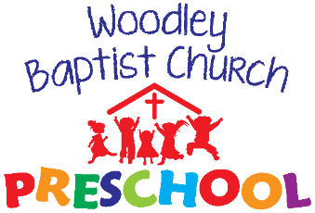
Tel: 9699956 or 07787793603
Website: www.woodleybaptistchurchpreschool.org
Email: preschool@woodleybc.org

Can we just remind everyone that if your child is sick or you have a last minute day out/at home for example, please
get in touch to let us know as early as possible. Please inform us in advance of any holidays, doctor’s appointments, or hospital visits. If you know your child is going to be late in for any reason, try and let us know at the session before. PLEASE NOTE: if no contact has been made with us by 10.30am staff will contact you so the reason for absence can be recorded.

