NEWSLETTER OCTOBER 2021
WOODLEY BAPTIST CHURCH PRESCHOOL
Friday 22nd October 2021
Dear Parents & Carers

The first half of this Autumn Term comes to an end and we break for Half Term today. We return on Monday 1st November 2021. As this is the first Newsletter of the new Preschool year there is lots of information to share.
This first seven weeks have flown by. We have had a busy time settling in all the new children that have joined us and welcoming all our new families as well as some who have returned! It is lovely to see the children now used to coming in each day and so busy and active throughout the morning. We hope you have enjoyed hearing about and seeing some of the things the children have been doing whilst learning & playing with such things as making their This is Me poster; dinosaurs; story telling; hedgehog breadmaking & our recent Road Safety roadshow.

We continue to operate in a different way due to the ongoing Coronavirus situation. As discussed in previous correspondence, although many restrictions are lifted, Preschool continues to run with protocols in place for the safety of all. As you are all aware there is a surge of community transmitted cases in the Wokingham area at the moment, which places more importance on the systems we have in place, so thank you for all your support. As a reminder – where possible only 1 adult drops off & collects your child to and from Preschool. When entering the building please ensure you are wearing a face covering (we are aware of those who have exemptions). Please use the hand sanitiser as you enter & if needed there is an additional one on the table with our noticeboard. Please respect those who wish to continue with social distancing. Should you or your child or any other household member show signs of the virus please do not come into Preschool. Please follow the current guidelines on taking PCR tests – see https://www.gov.uk/get-coronavirus-test Thank you.

Everyone has now activated their TAPESTRY online accounts to see observations made of the children. Thank you to those who have commented or added some observations of your own! Lovely to see some of the things the children do outside of Preschool as this helps us to build upon our knowledge of them, so as to support their learning & development. Everyone is welcome to add to the journals.

A reminder to everyone, especially new parents, to look at the Notice Board for information. There is also some very useful information in the red folder alongside the Notice board about services you may wish to access, such as the Children’s Centre at Ambleside; Speech & Language sessions; adult education; child health advice and children’s online activities from Wokingham libraries. Due to Covid-19, many of these groups continue to function online, so please check with them individually as to what is currently available.
Also check out our website at www.woodleybaptistchurchpreschool for latest updates and news.
Thank you to those who have been able to give the Voluntary Contribution for this year. These funds are greatly appreciated and are used towards many of our craft activities and the little extras we can sometimes provide for the children. We have had a good response this year but there are still a few forms not returned. Even if you are not able/do not wish to pay at this time, please indicate this on the form and return it to us as soon as possible. Please note that ALL CHILDREN benefit from these additional funds. If you wish to discuss this further or have any questions, please speak to Mrs. Sweeney. Thank you.
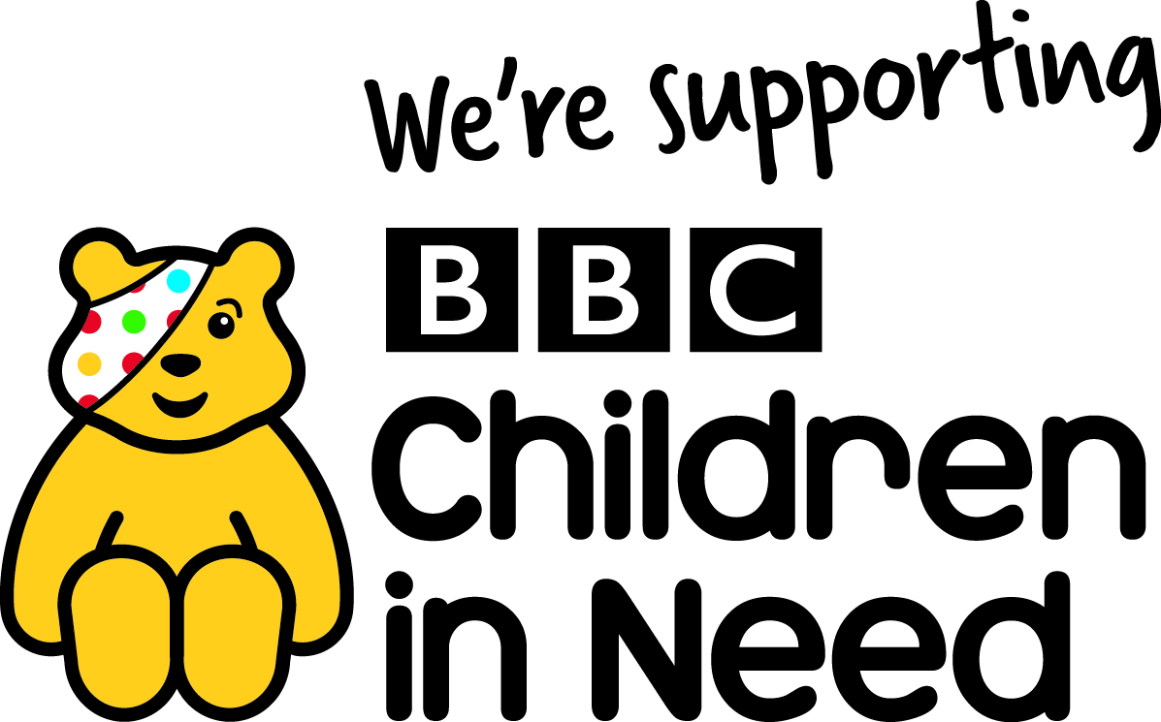
We hope to be supporting BBC Children in Need during the week of November 8th – 12th as always, despite the limitations there may be again this year. We hope to have a week of activities and a competition the children may wish to enter … more details to follow!

We will be having our Photographer into Preschool on Wednesday 10th November 2021. Please be assured the photographer has a lengthy risk assessment in place in order to ensure photos of the children can be taken safely & prints will be available in time for you to give as Christmas presents if you wish. For those who may know how we have done these photos in the past, please note unfortunately this year again, we are unable to include siblings. More details to come after Half Term.
Don’t forget to make sure everything that is brought into Preschool is named, especially coats and bags. A name on the OUTSIDE of the bag please. This is helpful to both children and staff when friends have very similar items & we must locate bags for any changes of clothing. No food, drink or medication should be left in these bags. Should any such items be brought into Preschool they can be left safely with a member of staff. Thank you.
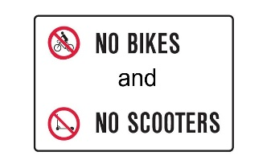
We have been asked that any bikes or scooters used by the children to get to Preschool are NOT RIDDEN into the Church building please. As wetter weather approaches this will leave mud and marks on the carpet areas, causing additional work to the cleaning staff. They are also being ridden around the main hall which is a danger to others. Buggies for younger siblings are of course acceptable. Bikes or scooters can be left in the foyer between the two sets of front doors, but security cannot be guaranteed.
***DATES FOR DIARIES***:
AUTUMN TERM CONTINUES FROM - Monday 1st November 2021
Children in Need – 8th – 12th November 2021
AUTUMN TERM ENDS – Friday 17th December 2021
Closed for Christmas Holiday – 20th December 2021 – 9th January 2021
Start of Spring Term – Monday 10th January 2022

If any of your contact details have recently changed, especially mobile phone numbers and email addresses, please don’t forget keep us informed!
Finally, should you have any questions, queries or comments please speak to a member of staff.
Thank you as always for your support of Preschool.
Have a good holiday.
WOODLEY BAPTIST CHURCH PRESCHOOL
Tel: 9699956/Mobile: 07787793603
Email: preschool@woodleybc.org
Website: www.woodleybaptistchurchpreschool.org

Can we just remind everyone that if your child is sick or you have a last-minute day out/at home for example, please could you telephone to let us know as early as possible? Please inform us in advance of any holidays, doctor’s appointments or hospital visits. If you know your child is going to be late in for any reason, try and let us know at the session before. PLEASE NOTE: if no contact has been made with us by 10.30am staff will contact you so the reason for absence can be recorded.

