NEWSLETTER APRIL 2021

WOODLEY BAPTIST CHURCH PRESCHOOL

Thursday 1st April 2021

Dear Parents/Carers,

With Easter falling early this year we finish the Spring Term today, Thursday 1st April 2021, returning to Preschool on Monday 19th April 2021.
Hopefully the children have had fun with all our activities this term from celebrating Mother’s Day, becoming Superheroes and in these last few days focusing on the true meaning of Easter, whilst enjoying a egg hunt and a ‘party style’ snack time. We also celebrated World Book Day on 4th March 2021 with the children wearing some fantastic costumes. Hopefully everyone has seen the photos in the Gallery on our website.
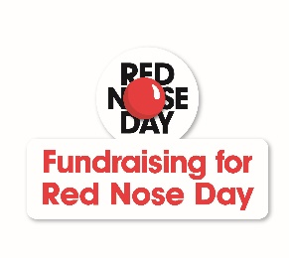
Despite the limitations due to all the COVID restrictions, we raised a fantastic £50.00 for Comic Relief with the children coming to Preschool dressed in red, helping to create a giant red collage, taking part in a red nosed face competition & decorating cakes to take home. Well done to Josie & Max for winning the competition with their lovely creations. Thank you to everyone for taking part and supporting this charity fund raiser in these difficult times.

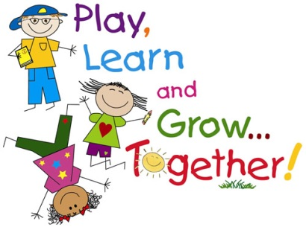
Everyone should by now have spoken to their child’s Key Person and read the Learning Journeys. Thank you for joining us to look at these records – especially as we had to spread appointments out & hold most of them in the garden! As always, we have received very positive feedback about this record of your child’s time at Preschool and a lot of thanks for keeping Preschool open during these very challenging times. As you can see the children continue to be busy learning through play. The next step for many is preparing for their transition to school in September 2021.

Please find with this Newsletter a ‘Sharing Observations from Home’ form for you to use to tell us about things your child may do over the Easter holidays that could be included in their Journeys. A few of the restrictions are starting to be lifted now, so if there are any exciting days out, activities at home or news that can be shared with us, that would be great.

Also, a reminder to parents of children going to school in September, you should be notified of their place by Friday 16th April 2021. When you return to us the following week we will be asking for confirmation of where your child will be going, so we can begin their transition process. The deadline for accepting places is Tuesday 4th May 2021. Please also let us know as soon as you have any details about school visits. Thank you.

Don’t forget to make sure everything that is brought into Preschool is clearly named, especially coats and bags. This is really helpful to both children and staff when friends have very similar items! We want to continue limiting what comes into Preschool at this time, so please do not leave other items with the children, such as umbrellas & toys from home. Don’t forget, for safety reasons we do not want plastic or drawstring bags in Preschool and no food or drink items in bags from home. Thank you.

As usual, some reminders about the rules in place during these times of COVID-19. We continue to work hard to ensure Preschool remains open and in doing so protect both staff and children.
At present these will continue to be in place next term.
- Continue to follow all the general rules – such as those about social distancing; wearing face coverings & taking tests if showing symptoms - & we will advise you if we receive any further information regarding Early Years settings specifically.
- One of the most important requests is that should anyone in your family show symptoms you get tested and NOONE attends the setting whilst awaiting results.
- If anyone should have a POSITIVE COVID-19 test during the Easter holidays please email preschool@woodleybc.org.
- The system of dropping off & collecting through the garden area continues to work well, so thank you all for your cooperation with this…but please DO NOT FORGET to wear a face covering...if you forget this, please do not enter the garden, a member of staff will be able to provide a mask for you to enable you to enter safely.
Thank you for your continued support.

PLEASE NOTE THAT FROM MONDAY 19TH APRIL 2021 THE STAGGERED COLLECTION TIME FROM PRESCHOOL WILL BE FROM 12.45PM – 1.00PM EVERYDAY INCLUDING FRIDAYS.

Please see below some of the main dates for the Summer Term. Apologies that we will have to CLOSE on Thursday 6th May 2021 as the Church building is to be used as a Polling station for the upcoming elections that were postponed from 2020. Please also note the May Bank Holiday.

DATES FOR DIARIES:
END OF SPRING TERM – Thursday 1st April 2021
START OF SUMMER TERM – Monday 19th April 2021
MAY BANK HOLIDAY – Monday 3rd May 2021– PRESCHOOL CLOSED
POLLING DAY – Thursday 6th May 2021– PRESCHOOL CLOSED
NEXT COMMITTEE MEETING – Tuesday 11th May 2021
HALF TERM – Monday 31st May – Friday 4th June 2021
END OF SUMMER TERM – Friday 16th July 2021

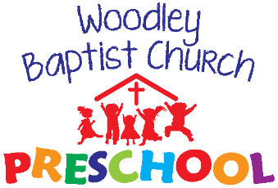
If any of your contact details have recently changed, especially mobile phone numbers and email addresses, please don’t forget keep us informed!
Finally, should you have any questions, queries or comments please speak to a member of staff.

Thank you as always for your support of Preschool. Have a lovely Easter break.

Tel: 9699956 or 07787793603
Website: www.woodleybaptistchurchpreschool.org
Email: preschool@woodleybc.org

Can we just remind everyone that if your child is sick or you have a last minute day out/at home for example, please
Get in touch to let us know as early as possible. Please inform us in advance of any holidays, doctor’s appointments or hospital visits. If you know your child is going to be late in for any reason, try and let us know at the session before. PLEASE NOTE: if no contact has been made with us by 10.30am staff will make contact with you so the reason for absence can be recorded.

